**535/2 PHYSICS**

1. (a) (i) **Distinguish between stress and strain.** (2 marks)

Stress -- force acting per unit area

Strain – Ratio of extension produced to its original length

(ii) **State two factors that affect the strength of a material.** (2marks)

- Nature of the materials

- Gross sectional area (diameter of material)

- Thickness of material

(b) (i) **what is meant by surface tension?**  (1 mark)

Surface tension is the force of attraction holding the surface of the liquid to appear as a stretched elastic skin

(ii) **Explain why mercury is depressed in a capillary tube.** (2marks)

-Temperature

- Addition of an impurity

-Using detergent

The cohesion of mercury molecules is greater than adhesion to glass the meriscus curves downwards followed by a capillary depression

(c) (i) **State Hooke’s law .**  (1mark)

Force is directly proportional to the extension, provided elastic limit is not exceeded for an elastic material

(ii) **Describe briefly an experiment to verify the law stated in c (i) above**  (4marks)

- Fix a pointer on spring and clamp it vertically against vertical scale

- Not the position of the pointer and suspend a known mass on the spring

-Note and record the new position of the pointer

- Obtain extension in spring

-Repeat the procedures above for different values of masses

-Plot a graph of e, vs mass

-A straight line graph through the origin verifies Hooke’s law

(d**) A force of 8N extends a spring by 2.1 cm. find the mass that can produce an extension of 6.3 cm.** 3 marks)

=

F2 = = 24N

Mass = $\frac{w}{g}$ = $\frac{24}{10}$ = 2.4 kg

1. (a) **State Newton’s laws of motion** (3marks)

-A body stays at rest or, if moving it continues to move with uniform velocity unless an external force makes it behave differently

-The rate of change of momentum is directly proportional to the applied force and it takes place in the direction of the force

-For every action there is equal and opposite reaction

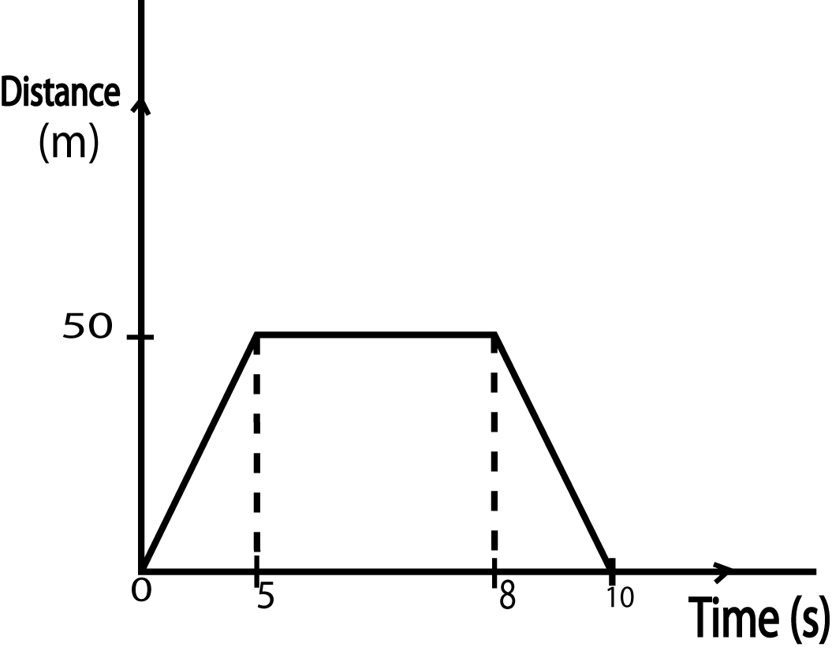(b) The diagram below shows the motion of a body

(i) **Describe its motion**. (3marks)

A body from rest moves a distance of 50M in %s. it rests for 3 secnds and then comes back to its original place in 2 seconds

(ii) **Find the total distance covered.** (2 marks)

50 + 50 = 100m

(c) **Explain why passengers in a vehicle need to fasten their seat belts**  (2 marks)

In a motion, a body moves at the same speed as that of a vehicle but when a driver suddenly brakes, a body tends to continue moving because of inertial and this may cause an accident. To avoid such incidents, passengers fasten their belts

(d) A mass of 50g travelling at 25ms-1 penetrates deeply into a fixed target and brought to rest in       25 seconds. Calculate.

(i) **Distance of penetration of the bullet**. (3marks)

a =

= = -12.5 ms-2

V2 = U2 – 2as

O2 = 252 – 2 x 12.5s

S5s = 625

S = ${625}/{25}$ = 25 m

(ii) **Average retarding force of the bullet.**  (3marks)

F = Ma

= $\frac{50}{1000}$ x -12.5

= -0.625N

1. (a) (i) **Define the term shadow.**  (1 mark)

A shadow is a region where light does not reach due to the obstruction by an opaque object

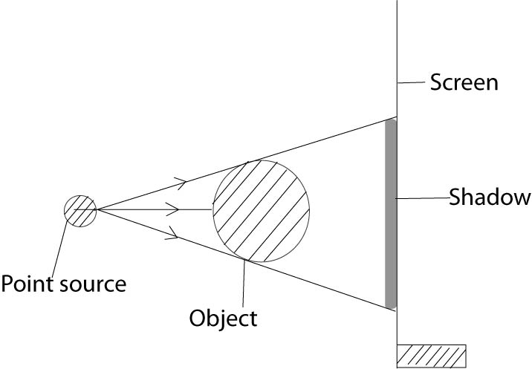(ii) Draw a well- labeled diagram to show the formation of a shadow when a point source is used. (3marks)

(b) (i) **Explain why the leaves of a bean plant appear green while its flowers appear yellow .**

(2marks)

- Primary colour – Which cannot be obtained by mixing other colour e.g red, blue and Green

* + Secondary colour – colours which can be obtained by mixing any two primary colours e.g Yellow, cyan and Magenta

Leaves appear green because they reflect green and absorb other colours flowers appear yellow because they reflect yellow a combination of green and red.

(c) **A ray of light incident on a material block. PQRS of refractive index 1.39 just emerges from the side as shown below.**

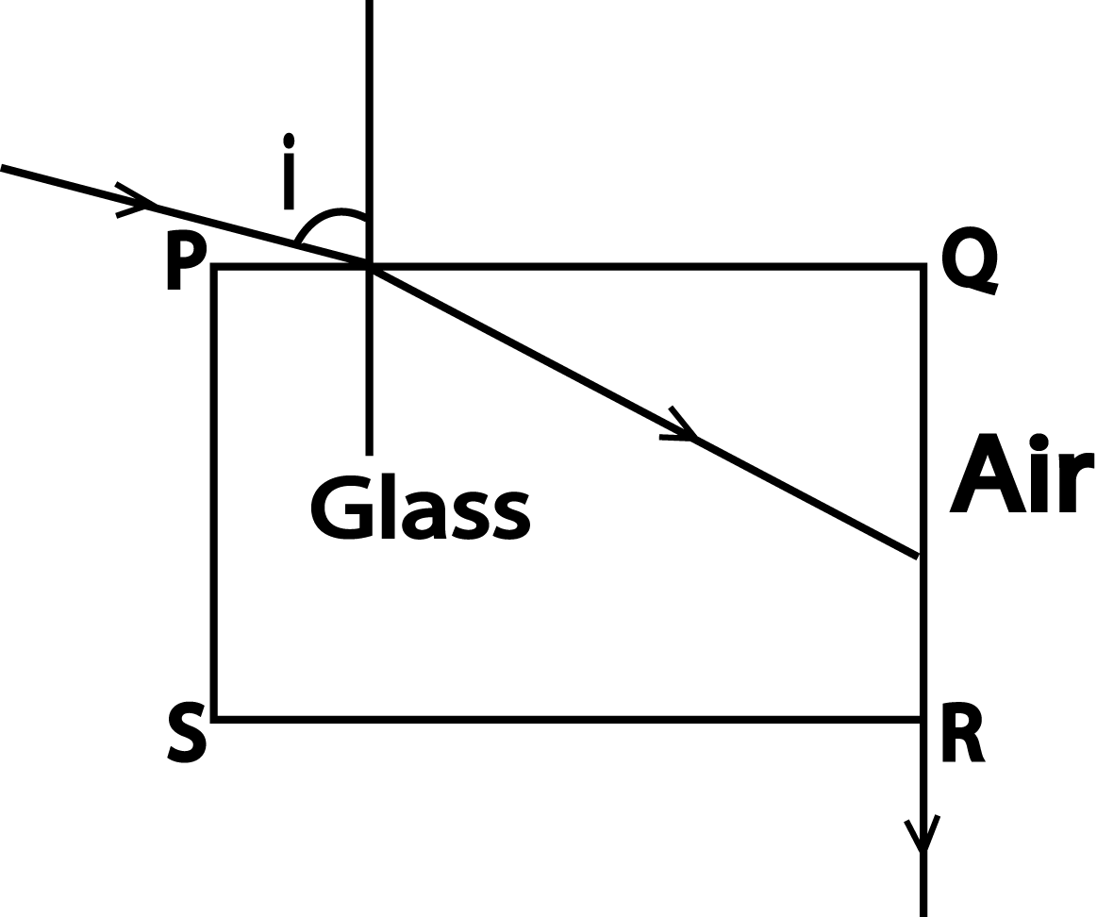

1. **Find the value of angle i**. (5marks)

Ng sin C = na sin 900

1.39 =

Sin I = 0.966

i = 74.9 (7500)

1. **State the conditions for total internal reflection to occur** (2 marks)

Angle of incidence must be greater than the eritical angle

1. (a) **What is meant by ;**

(i) **Reverberation**  (1mark)

Effect when original sound appears prolonged due to multiple reflection

(ii) **Interference**  (1mark)

When two identical waves travelling in the same direction are superposed on one another

(b) **Explain the following observations**

(i) The reception of FM radio station in mountainous areas is poor (2marks)

Fm have short wavelength so their magnitude spreading is low around obstacles

(ii) **The sky looks blue** (2marks)

Molecules in the air scatter blue light from the sun more than they scatter red light since its wave length is short

(c)(i) **A pipe of length 20cm is closed at one end.Calculate the frequency of the first over tune**  (3marks)

At first overtune

$ι$ = $\frac{3}{4}$ $ℷ$

$ℷ$ = $\frac{4ι}{3}$

= $\left(\frac{4 x 0.2}{3}\right)f$

f= 1275Hz

(ii) **Describe an experiment to show that sound requires a material medium for its transmission.** (4marks)

-An electric bell is enclosed in a bell jar connected to a vacuum pump

- When there is air inside and the electric bell is switched on loud sound is heard

- When air is gradually removed by means of a vacuum the loudness of sound goes on reducing

- When air is gradually removed by means of a vacuum the loudness of sound goes on reducing

- When the air is completely removed, no sound is head but the gong is seen vibrating this shows sound requires medium for transmission

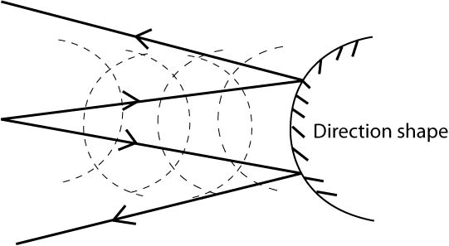(d) **Draw the resultant wave when circular wave fronts are reflected by a convex –shaped reflector.** (3marks)

1. (a) State the defects of a simple cell and how they can be minimized (4marks)

|  |  |
| --- | --- |
| Defect | How to minimize it |
| Polarization | Use a depolarizing agent e.g MnO4/Kcro4) |
| Local Action | Amalgamasation of zinc |

(b) The network of resistors connected to two cells of e.m.f 1.5 V and internal resistance of 2.0Ω each

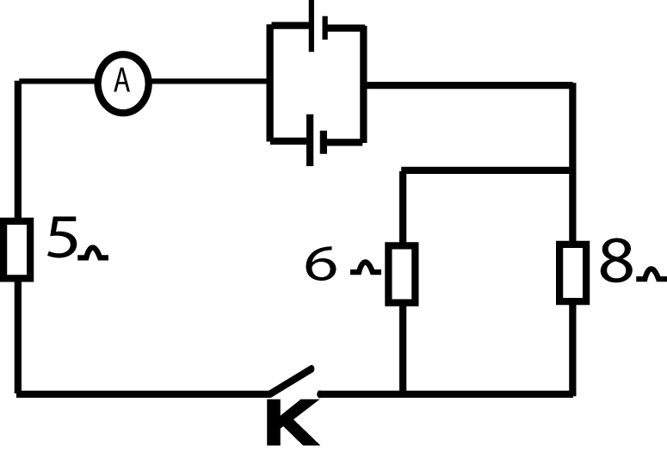

**Determine the**

(i) **Reading of the ammeter when the switch K is closed.** (3marks)

Effective resistance = 5 + ($\frac{2 x 2}{2+2}$) + ($\frac{6 x 8}{6+8}$)

= 9.43Ω

V = 1.5V

I = $\frac{V}{R}$ = $\frac{1.5}{9.43}$ $≈$ 0.16A

(ii) **Power disspated in the 5Ω resistor.**  (2marks)

Power developed P = 12R

= 0.162 x 5

0.13 W

(c) **Calculate the cost running an appliance marked 240V, 3000W for a week if it is used**

**40 minutes each day at a cost of 540/= per unit.** (3marks)

Energy = power x time

= $\frac{3000}{1000}$ x $\frac{40}{60}$ x 7

= 14kwl

Cost 14 x 540 = 7560/=

(d) (i) **Draw a well labeled diagram of a gold leaf electroscope**  (2 marks)

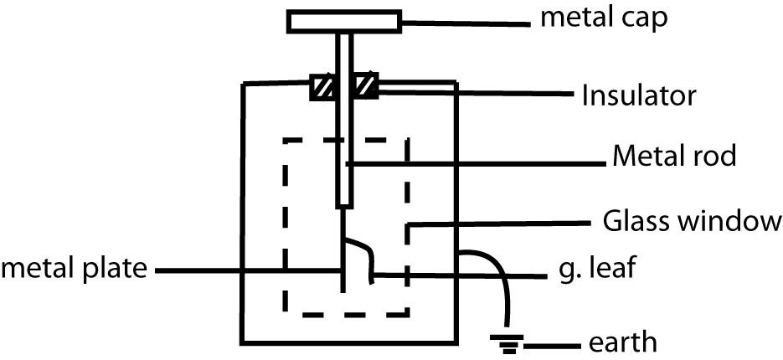

(ii) **State any two uses of gold leaf electroscope.**  (2marks)

* Detect presence of charge
* Test sign of charge
* Magnitude of charge

1. (a) **Define the term absolute zero and state its value.** (2marks)

Temperature at which molecules of a gas posses minimum kinetic energy 273k

(b) **Explain the following observations**.

(i**) On shore sea breezes on a warm afternoon**. (2marks)

Air molecules near earth are more heated, rise upwards since are less dense, vacuum space created over land.

Cool dense air from sea blow towards land to fill the vacuum space created fishing warm air losses heat and cools causing a sea breeze

(ii) **A thick-walled glass may crack when boiling water is poured into it**. (2marks)

Uniform distribution of heat is not achieved by outer and inside walls Tension between inner and outer wall is created thus setting up cracks

(c) Describe an experiment to verify the relationship between volume and temperature.

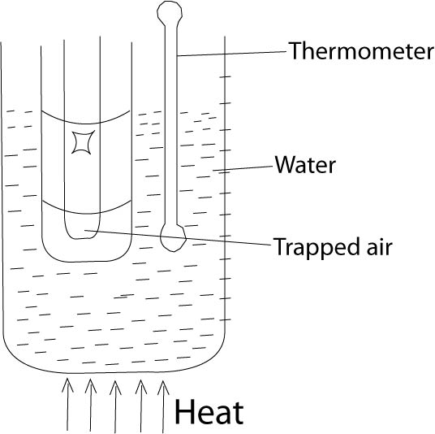(5marks)

* A volume of air is trapped using a drop of concentrated sulphuric acid and capillary tube is fixed on a scale using rubber bands
* Heating is done to the water bath and corresponding volume at each temperature are recorded
* Plot a graph of volume (Length of air column) against temperature (Kelvin) a straight line through origin shows V $∝$ T

(d) State two differences between boiling and evaporation. (2marks)

|  |  |
| --- | --- |
| Boiling | Evaporation |
| Occur throughout the liquid | Occurs at the surface |
| Occurs at specific temperature | Occurs at any temperature |

(e)An electric heater supplies 30J of energy every second. It is immersed in 0.05kg of oil. The temperature of oil rises from 200c to 500c in 100 seconds, what is the value of specific heat capacity of the oil. (3 marks)

Heat supplied by heater = heat gained by oil

Pt = Oil

30 x 100 = 0.05 x c x (50-20)

C = $\frac{30 x 100}{0.05 x 30}$

= 2000Jkg-1C0-1

1. (a) **State two properties of magnets.** (2marks)

* Attract magnetic materials
* Point N-S when freely suspended
* Like poles repel
* North pole attracts south pole

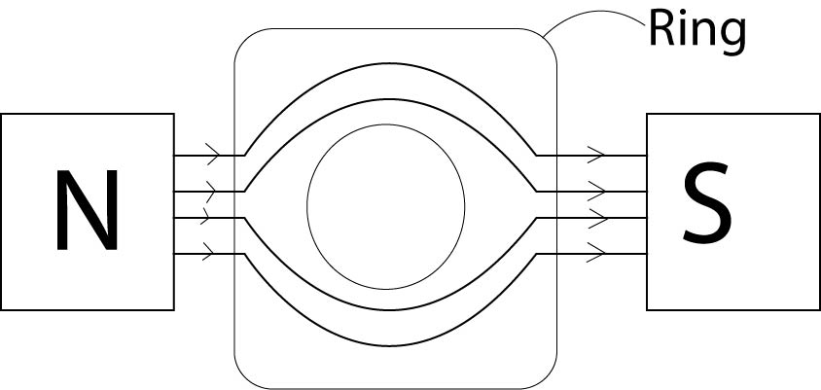(b) **With the aid of a labeled diagram, describe the effect of an iron ring placed in a magnetic field** (4marks)

* When an iron ring is placed between poles of a magnet it draws and concentrates field lines to itself
* No magnetic flux crosses the space inside the ring
* It is said to be screened it shielded from the magnetic flux

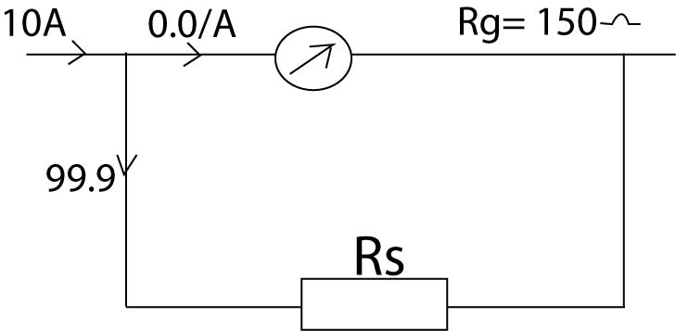(c) (i) **A galvanometer of resistance 150 $Ω$ gives a full scale deflection of 10mA. Calculate the  value of the resistor necessary to convert it to an ammeter reading to a maximum up to 10A.** (3marks)

Max: Ig = $\frac{10}{1000}$ = 0.01 A

Current through Rs = 10 – 0.01 = 9.99A

Vg = Vs

IgRg = Is Rs

Rs = = 0.15 $Ω$

(ii**) State three factors that determine the magnitude of force on a current carrying conductor.**

(3marks)

* Angle between the field and conductor
* Length of the conductor
* Magnitude of the current
* Strength of the magnet

(d) (i) **State two advantages of ac over dc in power transmission** . (2marks)

* a.c can easily and cheaply be changed from one voltage to another by a transformer
* a.c can easily be transmitted over long distances with minimum power losses

(ii) **Give two applications of electromagnets**. (2marks)

* Magnetic relays
* Electric bell
* Telephone receiver
* Electric motors
* Lifting magnets in steel mills

1. (a) **State two methods of producing electrons from a metal.** (2marks)

- Thermionic emission

- Photoelectric emission

(b) With the aid of a labeled diagram, describe how a diode is used to produce half wave       rectification. (5marks)

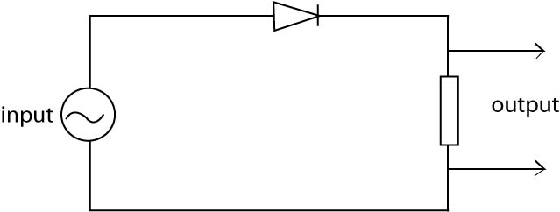

* When a.c is fed in the input, for the first positive cycle, current flows through the diode to output
* For the second negative half cycle current does not flow through the diode
* Therefore no current in the output thus a graph of output voltage against time appears

(c) The table shows the reading obtained from a count rate meter for the emission from a       radioactive sample of a radioactive nuclide

|  |  |  |  |  |  |  |
| --- | --- | --- | --- | --- | --- | --- |
| Count rate (s-1) | 132 | 86 | 56 | 38 | 24 | 15 |
| Time (years) | 0 | 1 | 2 | 3 | 4 | 5 |

Plot a suitable graph and determine;

(i) Half-life of the sample. (4marks)

(ii) The count-rate after 4 ½ years. (1 mark)

(d) A zinc rod is placed on a negatively charged gold leaf electroscope, then immediately with       ultra-violet light.

(i) **State the observations**. (1mark)

There is decrease in divergence of the leaf

(ii) and explain why. (3 marks)

Zinc plate loses electrons by photoelectric effect

Therefore the leaf and plate also lose electrons causing a decrease in divergence.

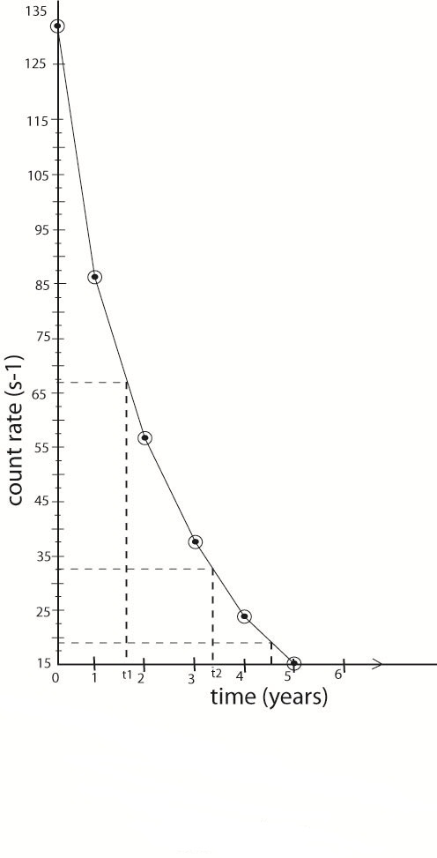

**END**